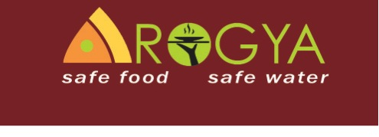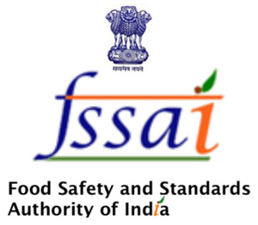

**Certificate of Participation – Food Safety Training**



**Food Safety Trainer**

Local vendors, trained to work as Food-Safety Trainers, conducted the training. The Training was organized by the joint cooperation of Dr. Reddy’s Foundation and the University of Goettingen/Sustainable Hyderabad Project, supported by Institute of Preventive Medicine, Dr. T. Neeraja of the Home Science College (ANGRAU) and other local Experts for Food Safety and Nutrition in Hyderabad.

**Sustainable Hyderabad – Pilot Project Coordinator**

We herewith certify, that___________________________________

has successfully participated four days in the

**Food Safety Training**

for Street Food Vendors in Hyderabad.